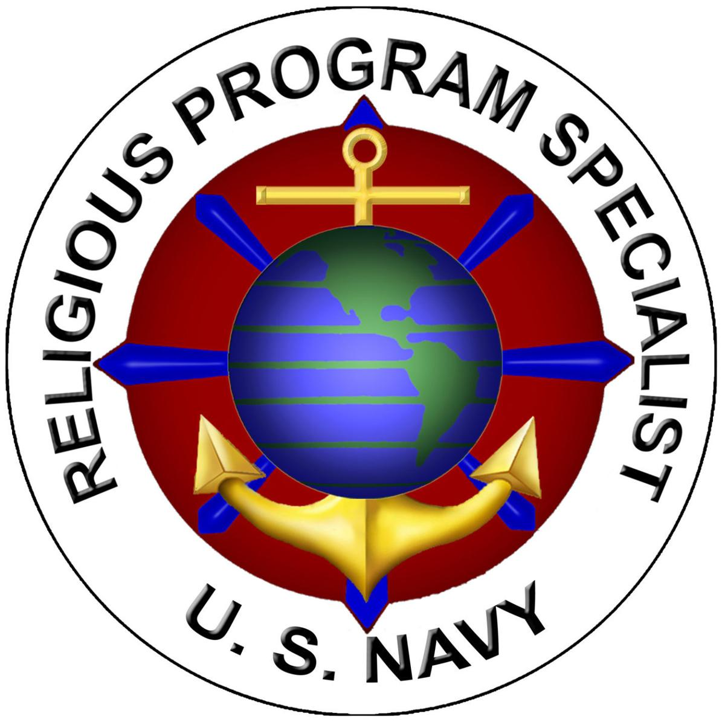

**Command Religious Program**

Marine Corps Security Force Regiment

**Nelson Chapel/NWS Yorktown Chapel** (757) 887-4711

1868 Lafayette Dr., Newport News, VA 23603

*Sunday*: Contemporary Protestant Service @1030

**Joint Base Langley-Eustis Base Chapel** (757) 878-1316

180 Dodd Blvd, Langley AFB, VA 23665

*Sunday*:

Catholic Mass@0930

Contemporary Protestant Service 1000-1100, Wylie Auditorium, Bldg. 705

Traditional Protestant Worship @1100

Latter Day Services 1000-1200, Family Life Center, Bldg. 1005

**NS Norfolk Chapel** (757) 444-7361

1530 Gilbert St., Norfolk, VA 23511

*Sunday*:

Catholic Mass @0930 (0900 Confession and 0915 Rosary)

Daily Mass, Mondays and Tuesday @ 1130

Protestant Worship @1030

*Thursday*:

Bible Study @1800

*Friday*:

Jewish Worship Service @1145

Muslim prayer @1300

**JEB Little Creek Chapel** (757) 462-7427

1160 D Street, Virginia Beach, VA 23459

*Sunday*:

Protestant Worship @1030

Catholic Mass @1215

**Naval Support Activity, Hampton Roads Northwest Annex** (757) 421-8204

4503 Relay Rd, Chesapeake, VA 23322

*Sunday*:

Protestant Worship @ 1830